**Publishing from ArcGIS Pro**

This document gives you the steps for publishing a web map from ArcGIS Pro.

**Prerequisites**

Make sure Active Portal in ArcGIS Pro is the publishing portal.

Make sure map data is accessible in ArcGIS Pro

**Best Practice**

* Using default symbology makes the map more reliable.

We can publish map service from ArcGIS Pro both in On-Premise and Azure Environment. Please follow the steps below,

**Publishing Process**:

**Step 1:** To publish in **On-Premise Environment**, Go to **Step 3** and follow the process.

To publish in **Azure Environment**, Go to **Step 2** and follow the process.

**Step 2**: Login to Jump Host using your login credentials. Username format should be

“**TRANSPORT\Username**”

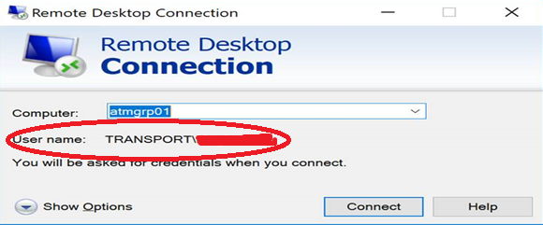

**Note**: Jump Host & Virtual Machine details are available in this [link](https://aucklandtransport.visualstudio.com/at_spatial/_wiki/wikis/AT_Spatial.wiki?pagePath=%2FGetting%20Started%2FWhat%20access%20do%20I%20need%3F%2FGIS%20Environments%20%252D%20Quick%20Reference&pageId=877&wikiVersion=GBwikiMaster).

**Step 3**: Start ArcGIS Pro and create/select the map document you want to share.

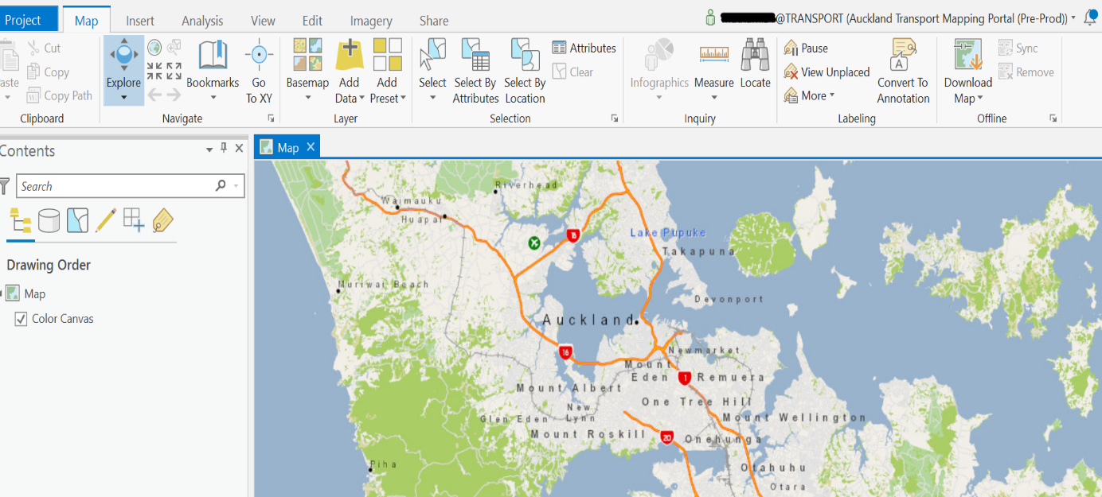

**Step 4**: Set the publishing portal as active portal in ArcGIS Pro by clicking on the little down button and switch the portal.



**Step 5**: Set the properties of the map by right clicking on the “Map” & select the “Properties”. Now the Map Properties window appears.

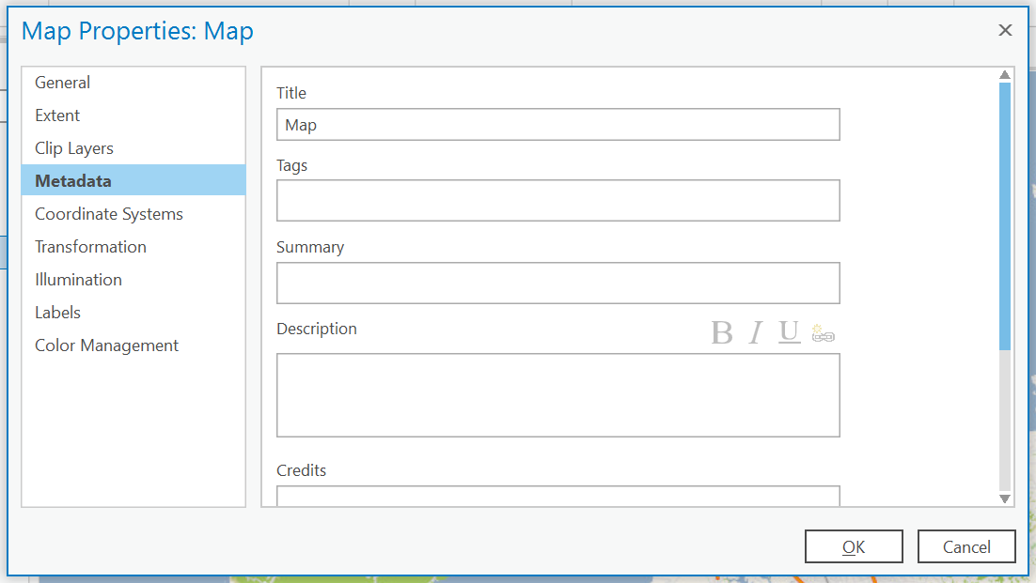

**Step 6**: Under the **Metadata** tab, update the information like “Title”, “Tags”, “Summary”, “Description”, “Credits”, and then click on “Generate Thumbnail”

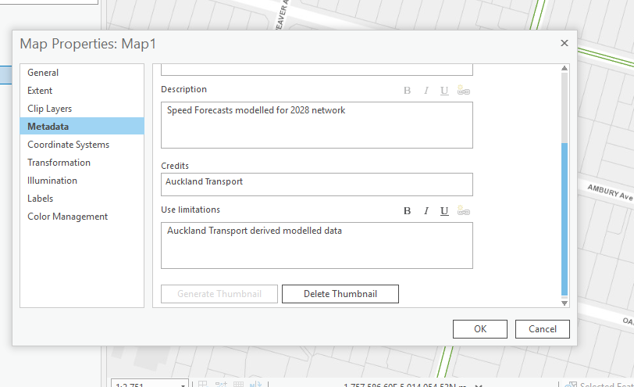

**Step 7**: To share the map, click **Share** on the top menu, and in the Share As group, click “**Web Map**”.

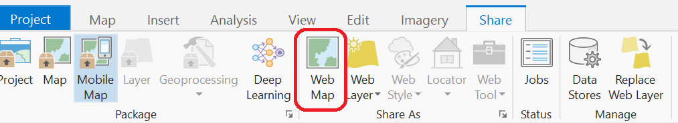

**Step 8**: Say **Yes** to the Security alert. Now the **Share As Web Map** window appears.

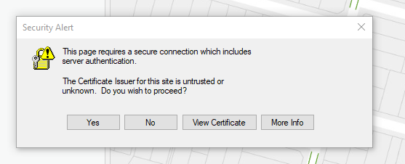

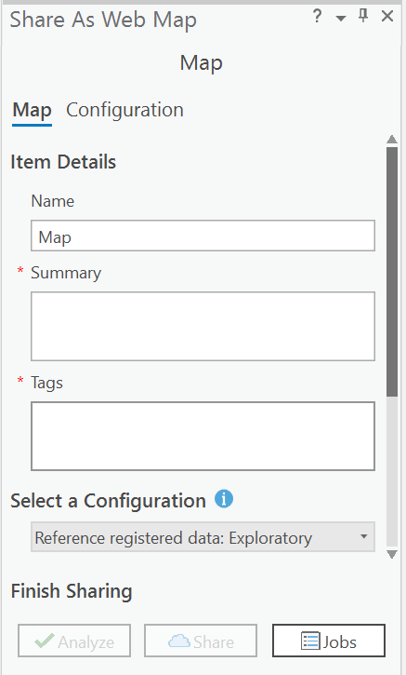

**Step 9**: Fill in the below details in the Share As Web Map dialogue,

* Name
* Summary
* Add the Tags. Make sure the keywords are separated by commas.
* Use Select a Configuration tab to select the configuration option based on the access privilege which is required to do certain set of tasks. Below table describes the different configuration options.

|  |  |
| --- | --- |
| **Reference registered data: Exploratory** | Input layers are shared as a map image layer. This interactive map supports querying and is ideal for displaying regularly updated data.  This configuration is not available when sharing to ArcGIS Online. |
| **Reference registered data: Editable** | Input layers are shared as map image layers with associated, editable feature layers. This editable map is ideal for enterprise editing workflows as the web layers honour data sources registered with the federated server.  This configuration is not available when sharing to ArcGIS Online. |
| **Reference registered data: Visualization** | Input layers are shared as a cached map image layer. Data is displayed as pre-generated tiles for fast visualization.  This configuration is not available when sharing to ArcGIS Online. |
| **Copy all data: Exploratory** | Input layers are shared as feature layers with editing turned off. Layers that are not supported by feature layers are shared as tile layers. |
| **Copy all data: Editable** | Input layers are shared as feature layers with editing turned on. Layers that are not supported by feature layers are shared as tile layers. This editable map is ideal for collecting data from external users who do not have access to your enterprise data. |
| **Copy all data: Visualization** | Input layers are shared as tile layers. Data is displayed as pre-generated tiles; their fast visualization makes them ideal for base maps. |

* Use location tab to select the folder where your web map will be stored in your portal content or you can create the new folder.
* Share with, select from below options based on your audience.
* **Everyone**—This option makes your content public. Anyone can access and see it.
* **My Organization**—If you are signed in with an organizational account, you see this option. This option allows your content to be shared with all authenticated users in the organization.
* **Groups**—You can share your content with groups you belong to and their members.

When sharing with Everyone, verify that all existing web layers can be accessed by individuals consuming the web map.

**Step 10**: Under the Finish Sharing tab, click **Analyze**.

**Step 11**: You may see errors and warning message which needs to be fixed before sharing the web map. Until the errors & warnings are fixed, repeat the “Analyze” step. [Learn more about analysing GIS resources](https://pro.arcgis.com/en/pro-app/help/sharing/overview/analyze-your-gis-resource.htm)

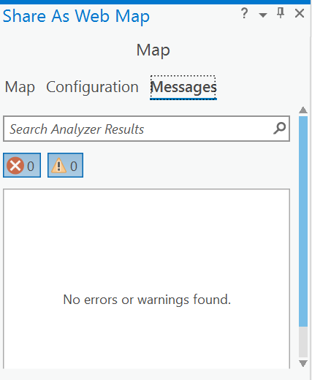

**Step 12**: Once the errors & warning messages are fixed, then click **Share** to share your web map, you will then see a progress of sharing at the bottom of the screen. It might take few minutes based on the network traffic, connection stability & other factors.

**Step 13**: Once the map is shared, a success message appears at the bottom of the screen.

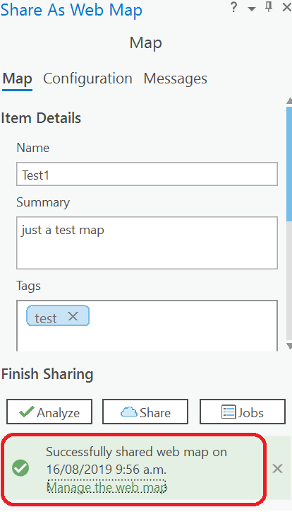

**Step 14**: Click Manage the web map link to explore the web maps.

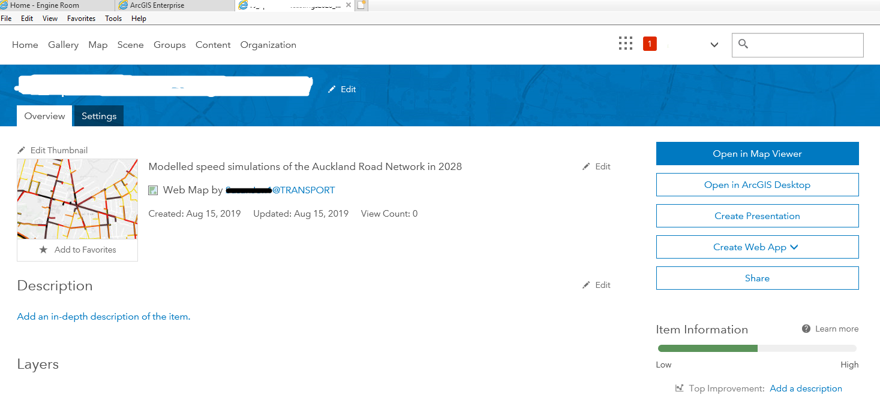

**Step 15**: The map's item page appears with the **Overview** tab selected at the top of the page. Before opening the web map, you'll add a description and terms of use statement.

**Step 16**: Click “Edit” to the right of the Description & update the description of the map

**Step 17**: Click “Save”.

**Step 18**: Scroll down to the Terms of Use, click Edit and update the terms of use field.

**Step 19**: Click “Save”.

**Step 20**: Now you can open, explore and modify the web map using ArcGIS Online.